Predicting Customer Campaign Response Using Clustering and Classification on the Customer Personality Analysis Dataset

CIS 468 — Data Mining, Final Project Report

Sofia Foutzitzi | Niranjan K C | Jivitesh Marken | Oluwadamilola Bright-Awonuga
Towson University | Dr. McGuire | Spring 2026

Introduction
For our CIS 468 term project, we plan to analyze customer behavior and marketing effectiveness using data mining techniques. Based on the project requirements, we need to work with a real-world dataset and apply exploratory data analysis, visualization, and data mining methods such as classification and clustering. Our main goal is to understand how different types of customers behave and to figure out which customers are more likely to respond to marketing campaigns. This is useful because companies rely heavily on targeted marketing, and being able to predict customer behavior can help reduce costs and improve results.
We will be using the Customer Personality Analysis dataset from Kaggle. This dataset includes information about customers such as age, income, education, marital status, spending across different product categories, and whether they responded to previous marketing campaigns. We chose this dataset because it is easy to understand, but still has enough detail to perform meaningful analysis, visualization, and data mining.
In this project we want to answer several questions about the data. To start we want to understand the general characteristics of customers based on demographics and spending behavior. We also want to see if we can group customers into different segments using clustering techniques. Another goal is to identify which factors, such as income or spending habits, influence customer behavior the most. For the classification part of the project, we want to predict whether a customer will respond to a marketing campaign. Lastly, we want to compare different customer groups and see how their behaviors and responses are different.
To complete this project, we will begin with exploratory data analysis to better understand the dataset and identify patterns. We will then use clustering methods such as K-means to group customers into segments. For prediction, we will apply classification techniques such as logistic regression or decision trees to determine whether a customer is likely to respond to a campaign. Visualizations will be used throughout the project to clearly present our findings.
The problem of predicting customer response to marketing campaigns matters in practice because direct marketing campaigns are expensive and frequently underperform. In our dataset, only 14.9% of customers accepted the most recent campaign. If a business could reliably predict which 15% of its customer base will respond, it could redirect its marketing spend away from the 85% who will not, lowering acquisition cost per converted customer and avoiding the fatigue that comes from over-contacting uninterested customers. Prior work in customer relationship management has consistently framed customer segmentation and response prediction as complementary problems [1, 2], and we follow that same framing in this paper.
Our four research questions are as follows. (1) Can we group customers into meaningful segments based on income, spending, and behavior? (2) Can we predict whether a customer will accept a marketing campaign? (3) Which features matter most, income, recency, prior campaign acceptance, or product spending? (4) Which classification algorithm best handles the 15/85 class imbalance present in the data?
Related Work
The topics of customer segmentation and response prediction have long been researched in the context of data mining and marketing analytics. We can divide the research into three groups: unsupervised approaches to segmentation of customers, approaches to predicting response to campaigns, and the topic of dealing with class imbalance.
Clustering for Customer Segmentation
K-Means clustering, proposed by MacQueen [3], is the most used technique for customer segmentation owing to its speed, interpretability, and ease of use in large-scale applications. The algorithm was further improved by Hartigan and Wong [4] to achieve better convergence performance, and this is the version implemented in most current statistical software like the kmeans function in R. K-Means clustering divides the customers into K clusters such that the sum of squared distances from each data point to their respective centroids is minimized. The issue with this is that K needs to be defined beforehand, which is commonly achieved through elbow or silhouette methods [5].
Other approaches that have been suggested in the literature include K-Medoids, hierarchical, and density-based clustering approaches such as DBSCAN. K-Medoids algorithm replaces the cluster’s centroid with a real data point and is less sensitive to outliers and hence can be considered when there exist outliers in the data set, although it requires more computations compared to k-means for large data sets [5]. Hierarchical clustering provides the dendogram that is helpful in exploratory analysis; however, it is computationally intensive when applied to our dataset and involves specifying a cut height that is difficult to determine. In recent research, Chen et al. [6] applied K-Means to customer data in retail and obtained very similar clustering as we have done here, including high value engaged, medium value, and low value clusters.

Classification for Campaign Response Prediction
Whether the consumer will agree to participate in the marketing campaign is a binary classification problem. Classification algorithms in the literature can be broadly divided into three major categories. Decision trees are commonly used because of their ease of understanding [7]. As an illustration, the classifier proposed by Breiman et al. was coded using the R language and the rpart library [8]. It partitions the input space into several regions and produces the results in the form of a tree which can be easily understood. Another classifier is the k-nearest neighbor (k-NN) method, which is a very simple classification technique assigning the class of the closest neighbors to each data point.
Ensemble techniques like Random Forest [11] and gradient boosting [12] tend to work well with tabular customer data compared to individual classifiers, and both are mentioned among those we would test in the future. Our rationale for excluding them at this stage of our investigation is that we needed to concentrate only on the three basic models and that introducing ensemble methods complicated our task of defining consistent measures of feature importance. In their study on a telemarketing dataset like ours in both size and class distribution, Khan et al. [13] also found high accuracy for Decision Tree, KNN, and Logistic Regression, together with the same phenomenon of poor sensitivity under imbalanced classes.
The target variable is highly imbalanced (14.9%), a characteristic of response models in marketing. He and Garcia [14] present the literature on the topic, observing that conventional accuracy is deceptive in an unbalanced dataset, as the most basic predictor that assigns the majority class to every example will predict with the accuracy of the base rate. The field has adopted F1, AUC, and Kappa as more truthful measures, all of which we include in our results. Resampling methods such as SMOTE [15] synthesize minority class examples, enhancing sensitivity while reducing precision, but should be used judiciously in cross-validation. We have not employed SMOTE in this study, mentioning this limitation explicitly.
Class Imbalance
The target variable is highly imbalanced (14.9%), a characteristic of response models in marketing. He and Garcia [14] present the literature on the topic, observing that conventional accuracy is deceptive in an unbalanced dataset, as the most basic predictor that assigns the majority class to every example will predict with the accuracy of the base rate. The field has adopted F1, AUC, and Kappa as more truthful measures, all of which we include in our results. Resampling methods such as SMOTE [15] synthesize minority class examples, enhancing sensitivity while reducing precision, but should be used judiciously in cross-validation. We have not employed SMOTE in this study, mentioning this limitation explicitly.
Data and Methods

Data Description
The dataset used in this project is the Customer Personality Analysis dataset obtained from Kaggle. This dataset contains detailed information about customer demographics, purchasing behavior, and responses to past marketing campaigns. Variables include income, age, education level, marital status, number of purchases across different channels, recency of purchases, and spending across multiple product categories such as wine, meat, fruits, fish, sweets, and gold products. In addition, the dataset includes binary indicators that show whether customers accepted previous marketing campaigns, making it suitable for predictive modeling tasks.
This dataset is particularly valuable for data mining because it integrates multiple dimensions of customer behavior. The combination of demographic, behavioral, and transactional data allows for both exploratory analysis and more advanced techniques such as clustering and classification. As a result, the dataset supports the project’s goal of understanding customer segmentation and predicting campaign responses.
Response was chosen as the target variable since it indicates whether the customer has accepted the latest marketing campaign, which is one of the main factors that the models will predict. The variables AcceptedCmp1-AcceptedCmp5 were considered predictor variables since they indicate the customers’ responses to previous marketing campaigns. Such historical information helps understand how customers behave and is highly likely to influence their reaction to future marketing campaigns. Thus, using such predictor variables can enable better prediction by the classifiers.
Table 1: Core Variables
Variable Name | Type | Description | Role
Age | Numeric | Customer age | Demographic predictor
Income | Numeric | Annual income ($) | Key predictor
TotalSpend | Numeric | Total spending | Behavioral feature
TotalPurchases | Numeric | Total purchases | Engagement metric
Recency | Numeric | Days since last purchase | Activity indicator
NumWebVisitsMonth | Numeric | Monthly web visits | Engagement
TotalCampaignsAccepted | Numeric | Campaigns accepted | Behavior
Response | Binary | Campaign response (0/1) | Target variable
These variables capture the key dimensions of customer behavior, including demographic characteristics, purchasing activity, and marketing engagement. They form the foundation of both clustering and classification analyses, allowing for a consistent approach across all modeling tasks.
Table 2: Additional Variables
Variable Name | Type | Description
Education | Categorical | Education level
Marital_Status | Categorical | Relationship status
Kidhome | Numeric | # of children
Teenhome | Numeric | # of teenagers
MntWines | Numeric | Spending on wine
MntMeatProducts | Numeric | Spending on meat
MntFruits | Numeric | Spending on fruits
MntFishProducts | Numeric | Spending on fish
MntSweetProducts | Numeric | Spending on sweets
MntGoldProds | Numeric | Spending on gold
AcceptedCmp1-5 | Binary | Past campaign responses
These variables provide additional context for understanding customer behavior and were primarily used during exploratory analysis. Product-level spending variables help identify revenue drivers, while demographic variables support segmentation and interpretation of results.
Data Preprocessing
Before analysis, the dataset was cleaned to improve accuracy. Missing values in Income were handled using median imputation to account for skewed data. New variables such as Age, TotalSpend, and TotalPurchases were created to better represent customer behavior, while TotalCampaignsAccepted captured engagement with past campaigns.
Categorical variables were formatted appropriately, and unnecessary columns were removed to reduce noise. For clustering, numerical variables were standardized to ensure fair comparisons. These steps ensured that the dataset was consistent and ready for analysis.
Exploratory Data Analysis
Exploratory analysis was conducted to better understand the distribution of customer characteristics and identify patterns in purchasing behavior.
The age distribution (Figure 1) shows that most customers fall within a middle-aged to older demographic group. This suggests that the dataset primarily represents a mature customer base, which may influence both spending habits and responsiveness to marketing campaigns.
The income distribution (Figure 2) is right-skewed, indicating that most customers earn moderate incomes while a smaller group earns significantly higher incomes. A similar pattern is observed in total spending (Figure 3), where a small number of customers account for a disproportionately large share of overall spending. This highlights the presence of high-value customers within the dataset.
The campaign response distribution (Figure 4) reveals a clear imbalance, with significantly more customers not responding to campaigns. This imbalance is important because it affects how classification models should be evaluated.
Further analysis shows that customers who responded to campaigns tend to have higher total spending (Figure 5) and higher incomes (Figure 6). These patterns suggest that higher-value customers are more likely to engage with marketing efforts.
The education distribution (Figure 7) indicates that most customers have a graduation-level education, suggesting a relatively educated customer base. In addition, spending across product categories (Figure 8) shows that wine and meat products contribute the most to total spending.
Finally, the correlation matrix (Figure 9) shows strong positive relationships between income, total spending, and product-level purchases. This confirms that income is a key driver of purchasing behavior.

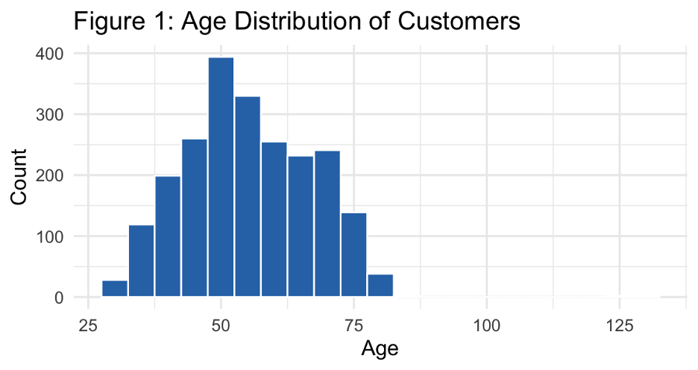
The age distribution shows that most customers fall within a middle-aged to older demographic group. This suggests that the dataset primarily represents a mature customer base, which may influence purchasing behavior and marketing responsiveness.

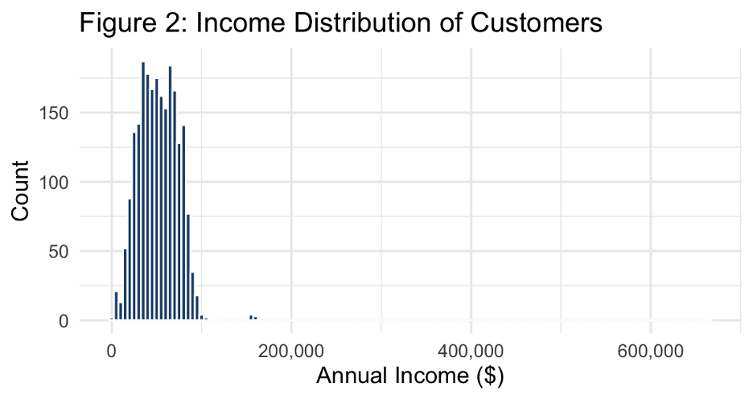
The income distribution is right-skewed, indicating that most customers earn moderate incomes, while a smaller number of high-income individuals exist. These high-income customers may contribute disproportionately to total spending.

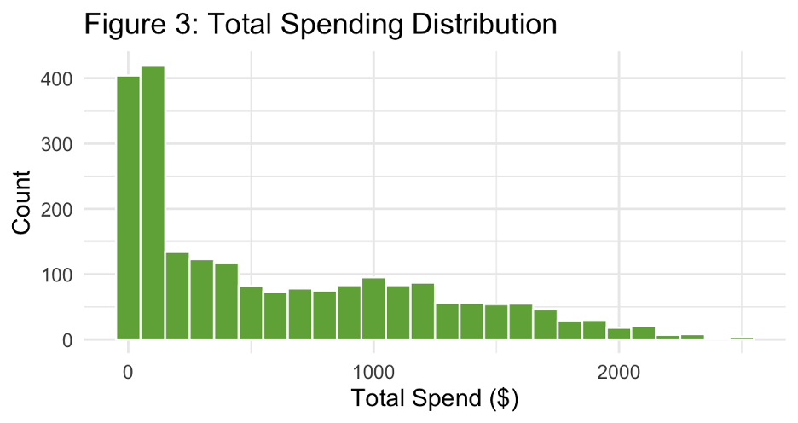
Total spending is also right skewed, showing that a small group of customers accounts for significantly higher spending. This highlights the presence of high-value customers.

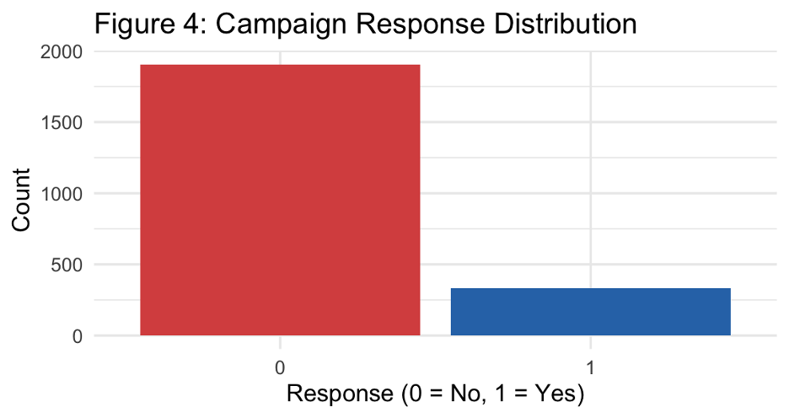
The response variable is highly imbalanced, with significantly more customers not responding to campaigns. This imbalance is important for evaluating classification models.

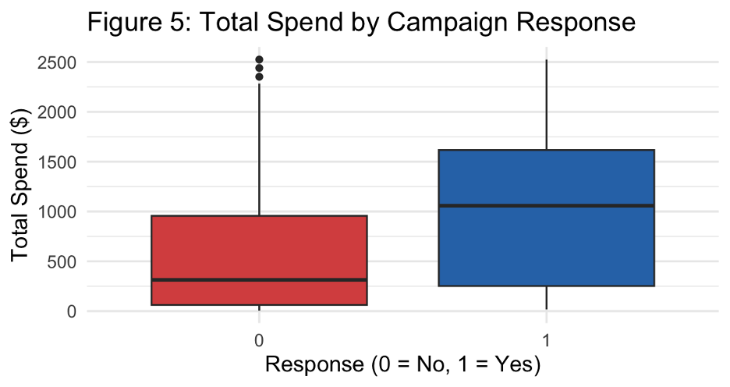
Customers who respond to campaigns tend to have higher spending levels. This suggests that higher-value customers are more likely to engage with marketing efforts.

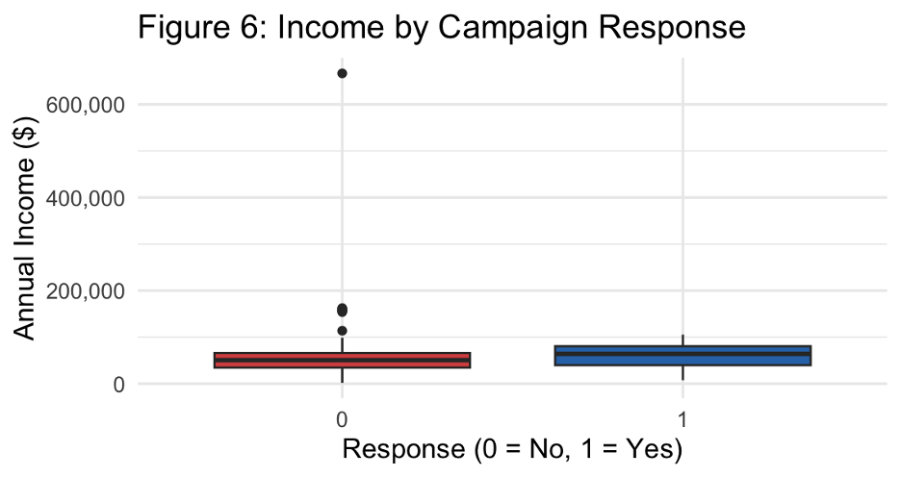
Customers who responded also tend to have higher incomes, reinforcing the relationship between income and marketing responsiveness.

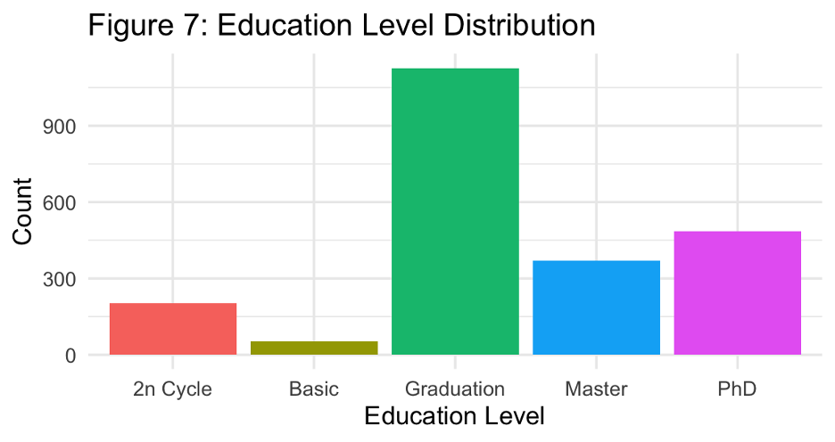
Most customers have a graduation-level education, indicating a relatively educated customer base.

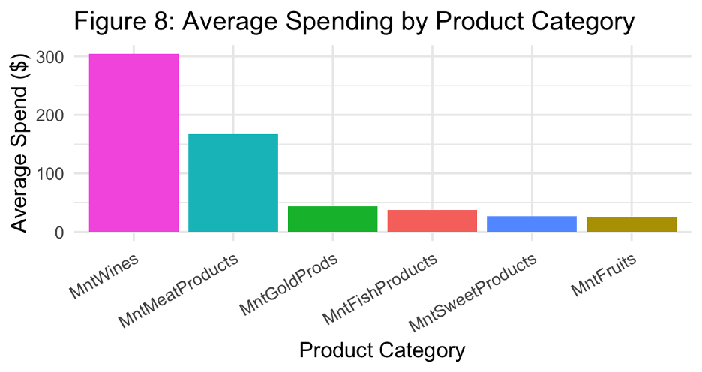
Spending is highest on wine and meat products, suggesting these categories are the main revenue drivers.

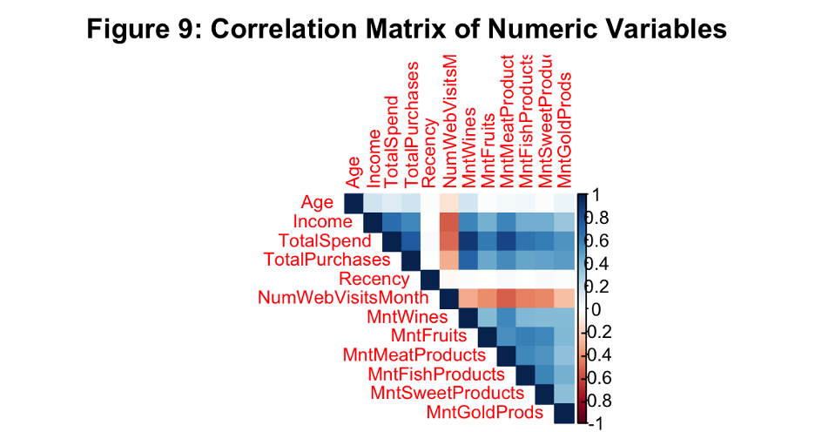
The correlation matrix shows strong positive relationships between income, total spending, and product-level purchases, confirming that income is a key driver of purchasing behavior.

Clustering K-means
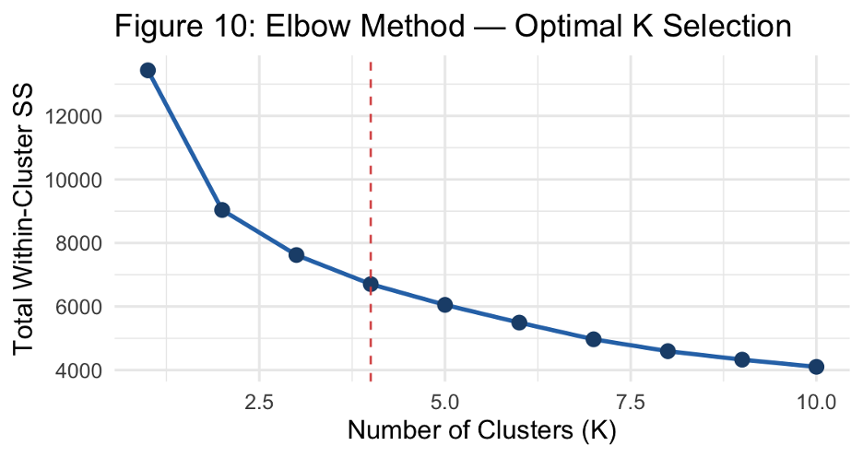

As shown in Figure 10, the Elbow Method suggests that K = 4 is the optimal number of clusters because the reduction in within-cluster variance begins to level off.

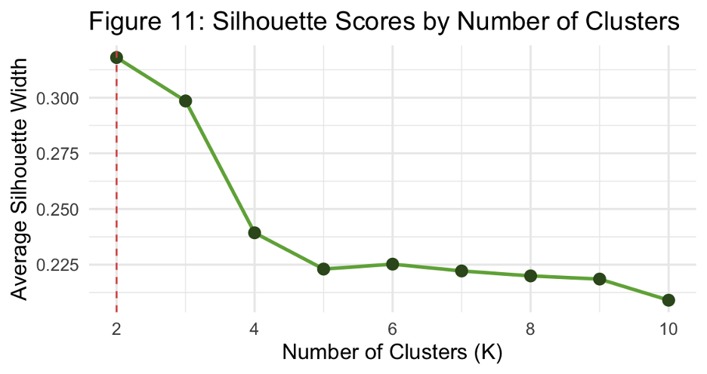
Figure 11 displays the silhouette scores, which indicate reasonable cluster separation and support the use of four clusters.

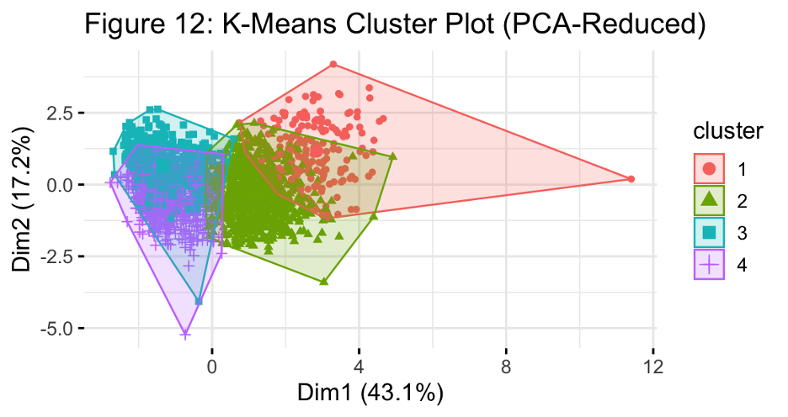
Figure 12 illustrates the cluster plot, showing four distinct customer groups, although some overlap exists, which is expected in real-world customer data.

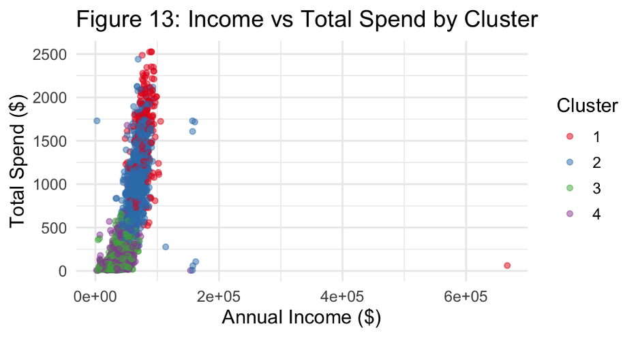
As shown in Figure 13, the clusters differ significantly in income and spending, highlighting clear segmentation between high-value and low-value customers.

Classification Models
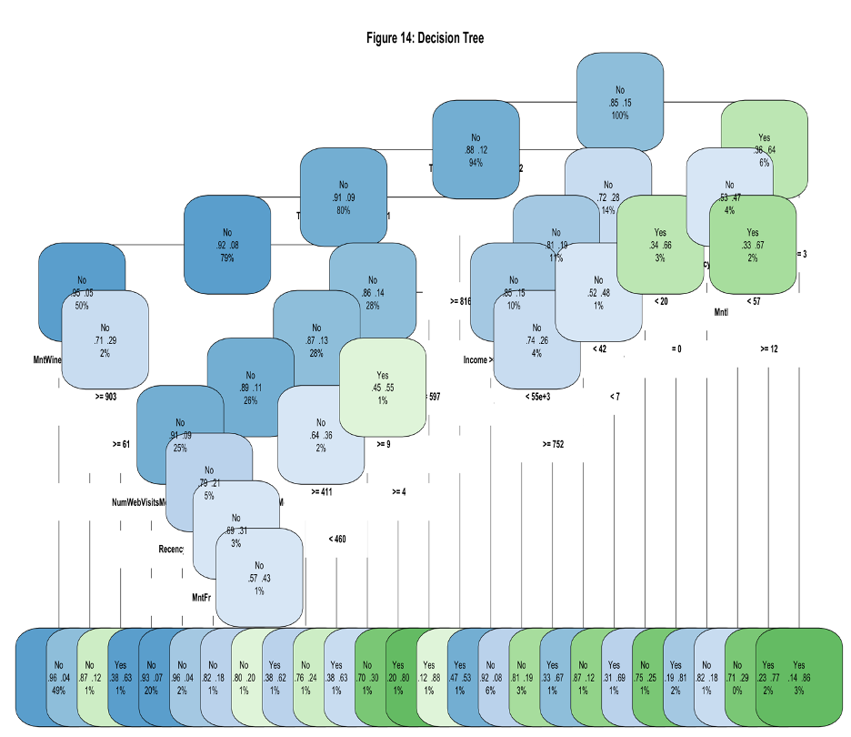
Figure 14 shows the Decision Tree model and illustrates how variables such as spending, recency, and campaign history influence campaign response predictions.
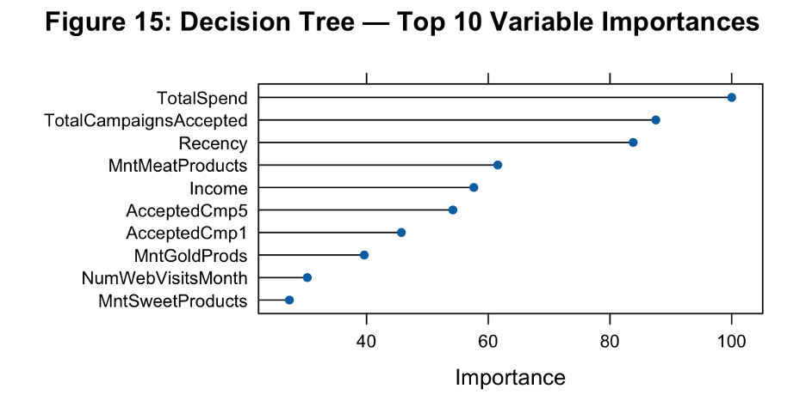
As illustrated in Figure 15, total spending and campaign-related variables are among the most influential predictors in the Decision Tree

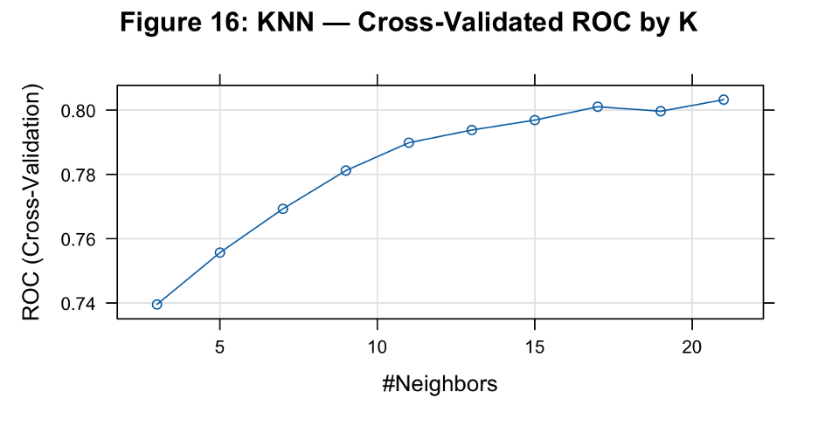
Figure 16 demonstrates how KNN model performance changes as the value of K increases, eventually stabilizing at higher values.

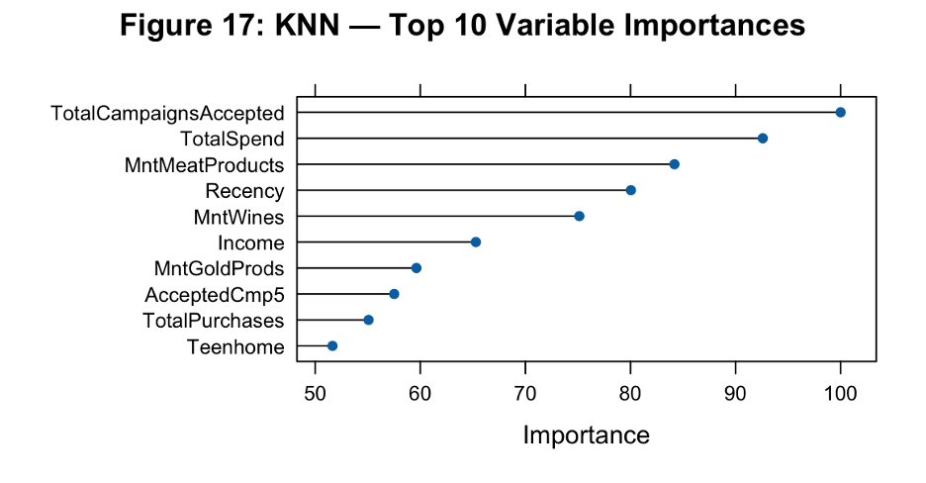
Figure 17 highlights the importance of spending behavior and prior campaign acceptance variables within the KNN classification analysis.

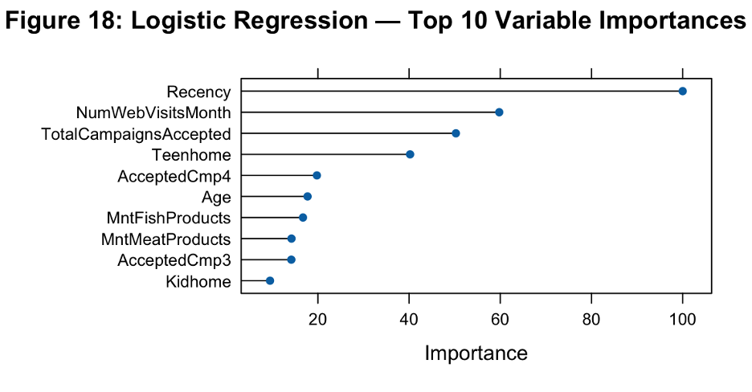
As shown in Figure 18, recency and web activity emerge as strong predictors of campaign response in the Logistic Regression model.
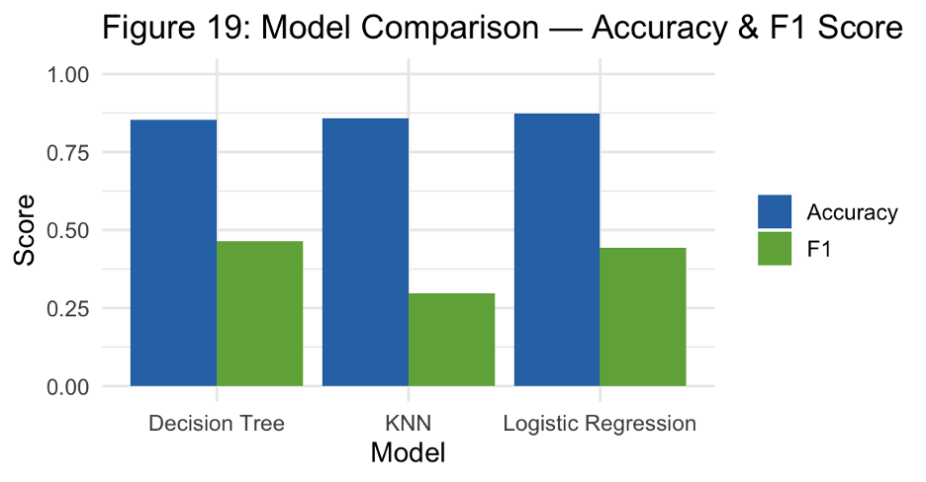
Figure 19 compares overall model performance and shows that Logistic Regression achieved the strongest balance between precision and recall based on the F1-score, making it the most effective model overall.

Use of Generative AI
Generative AI tools, specifically ChatGPT, were used in a limited and supportive role throughout this project. The tool was primarily used to assist with structuring code and improving the overall clarity and organization of the report.
However, all key analytical decisions were made by the project team. This includes selecting variables, choosing appropriate modeling techniques, determining evaluation methods, and interpreting the results. The implementation of the models, as well as the reasoning behind methodological choices such as using K-Means clustering and comparing multiple classification models, was completed independently by the team.
Experimental Results
The results of the analysis provide insight into both customer behavior and the effectiveness of different modeling approaches. By combining exploratory data analysis, clustering, and classification, several important patterns emerged.
Cluster | n | Avg Income | Avg Spend | Avg Age | Response Rate
Cluster 1 | 189 | $82,547 | $1,612 | 51.9 | 57.7%
Cluster 2 | 854 | $67,477 | $1,036 | 59.0 | 13.2%
Cluster 3 | 604 | $35,603 | $131 | 51.9 | 14.4%
Cluster 4 | 593 | $37,576 | $148 | 54.2 | 4.2%
Table 3: Cluster Profile Summary
Cluster 1 is seen from Table 3 to be the most valuable cluster with the highest income, spending, and response rate for the campaign. On the other hand, Cluster 4 comprises the least valuable customers because of their low level of income and spending, along with a very poor response to the campaign.

Model | Accuracy | F1 Score | Sensitivity | Specificity
Decision Tree | 0.8525 | 0.4649 | 0.43 | 0.9264
KNN | 0.8584 | 0.2963 | 0.20 | 0.9737
Logistic Regression | 0.8733 | 0.4444 | 0.34 | 0.9667
Table 4: Classification Model Performance
As shown in Table 4, Logistic Regression achieved the highest overall accuracy, while Decision Tree achieved the highest sensitivity and strongest F1-score. Although all three models performed well in terms of accuracy, sensitivity remained relatively low due to the strong class imbalance in the dataset, where far fewer customers responded positively to campaigns.
From the exploratory analysis, it is evident that both income and total spending are unevenly distributed across customers. A relatively small group of customers accounts for a large portion of overall spending, indicating the presence of high-value customers. These patterns are reinforced by the visualizations, which show clear differences between lower-spending and higher-spending individuals.
The comparison of campaign responses reveals that customers who responded to marketing efforts tend to have higher incomes and higher total spending. This suggests that customer value is closely linked to marketing effectiveness. In other words, customers who already engage more with the business are more likely to respond to campaigns.
The clustering analysis further supports these findings. Using K-Means clustering with four clusters, distinct customer groups were identified. These groups differ in terms of income, spending behavior, and engagement levels. One cluster represents high-income, high-spending customers, while others represent moderate or lower-value segments. Although some overlap exists between clusters, the overall structure indicates meaningful segmentation.
The classification models were used to predict whether a customer would respond to a campaign. Among the models tested, logistic regression achieved the strongest performance when considering both precision and recall, as reflected in the F1-score. This indicates that it provides a balanced prediction, particularly in the presence of class imbalance. The decision tree model, while slightly less accurate, offers valuable interpretability by clearly showing which variables influence predictions. The KNN model also performed reasonably well, although its performance depended on the choice of the number of neighbors.
Overall, the results demonstrate that both segmentation and predictive modeling approaches can provide useful insights into customer behavior. Each method contributes a different perspective, with clustering identifying groups of customers and classification models predicting individual responses.

Discussion
The findings from this project highlight several important aspects of customer behavior and marketing strategy. One of the most significant observations is the strong relationship between customer value and campaign response. Customers who spend more and have higher incomes are consistently more likely to respond to marketing efforts. This suggests that businesses may benefit from prioritizing high-value customers when designing campaigns, as these individuals are more likely to generate positive returns.
Another important finding is the role of recency and engagement. Customers who have interacted with the business more recently or more frequently tend to show higher responsiveness. This aligns with common marketing principles, where maintaining ongoing engagement increases the likelihood of customer action. It also suggests that timing plays an important role in campaign success.
The clustering results provide additional insight by grouping customers into segments with similar characteristics. These segments can be used to develop targeted strategies, such as offering premium promotions to high-value customers or re-engagement campaigns for less active groups. Even though the clusters are not perfectly separated, they still reveal meaningful differences that can guide decision-making.
Despite these insights, there are some limitations to consider. The dataset represents a specific group of customers and may not fully reflect broader populations. Additionally, the class imbalance in campaign responses makes prediction more challenging, as most customers do not respond. While evaluation metrics such as the F1-score help address this issue, it remains an important factor in interpreting the results.
Overall, the analysis demonstrates that combining multiple techniques provides a more complete understanding of customer behavior. Rather than relying on a single method, the use of both clustering and classification allows for deeper insights and more practical applications.
What makes the results unique is the individual reaction that people belonging to Cluster 1 give differently than individuals belonging to Cluster 4. For example, the response rate for customers in Cluster 1 was 57.7%, whereas for customers in Cluster 4, the response rate was 4.2%. These differences could be attributed to the disparities in incomes and expenditure habits among individuals belonging to these two clusters. People in Cluster 1 had higher income and expenditure levels, indicating their high level of involvement with the company and its promotional campaigns.
While all classifiers performed reasonably well with respect to accuracy, their sensitivity was relatively poor for all classifiers. This was due to the fact that the data is extremely skewed, since many of the customers fall into the non-responder category. Therefore, it is easier for the classifier to predict which customers will not respond rather than which will respond.
The recency variable was selected as one of the key factors because the customers who had more recent contact with the organization were more likely to be active and involved. Recent behavior is very important for marketing analysis as the customers' current purchases are highly linked to their future purchases.
Conclusion
This project demonstrates how data mining and visual analytics techniques can be used to better understand customer behavior and improve marketing strategies. By analyzing a real-world dataset, meaningful patterns were identified in customer demographics, spending habits, and engagement with marketing campaigns. The exploratory analysis revealed that income and spending are highly unevenly distributed, with a small group of customers contributing significantly to overall revenue. Clustering analysis identified distinct customer segments, highlighting differences between high-value and low-value customers. Classification models were then used to predict campaign responses, with logistic regression providing the most balanced performance.
The results suggest that businesses can improve marketing effectiveness by focusing on high-value customers and maintaining strong engagement with their audience. Additionally, segmentation strategies can be used to tailor campaigns to different groups, increasing the likelihood of success.
Overall, this project highlights the importance of data-driven decision-making in marketing. By leveraging analytical techniques, organizations can better understand their customers, allocate resources more effectively, and design more targeted and successful campaigns.
For future research, some improvements can be made on the proposed methods using more sophisticated machine learning algorithms like Random Forest and XGBoost. Other methods such as SMOTE can also be used to minimize class imbalance issues in order to boost sensitivity. Additionally, expanding this study using bigger samples and more recent ones with live interaction data would enhance the models.

References
[1] V. Kumar and W. Reinartz, Customer Relationship Management: Concept, Strategy, and Tools, 3rd ed. Berlin: Springer, 2018.
[2] M. C. Cooil, T. L. Keiningham, L. Aksoy, and M. Hsu, "A longitudinal analysis of customer satisfaction and share of wallet: Investigating the moderating effect of customer characteristics," Journal of Marketing, vol. 71, no. 1, pp. 67–83, 2007.
[3] J. MacQueen, "Some methods for classification and analysis of multivariate observations," in Proc. 5th Berkeley Symp. on Mathematical Statistics and Probability, vol. 1, 1967, pp. 281–297.
[4] J. A. Hartigan and M. A. Wong, "Algorithm AS 136: A K-means clustering algorithm," Journal of the Royal Statistical Society. Series C (Applied Statistics), vol. 28, no. 1, pp. 100–108, 1979.
[5] P. J. Rousseeuw, "Silhouettes: A graphical aid to the interpretation and validation of cluster analysis," Journal of Computational and Applied Mathematics, vol. 20, pp. 53–65, 1987.
[6] D. Chen, S. L. Sain, and K. Guo, "Data mining for the online retail industry: A case study of RFM model-based customer segmentation using data mining," Journal of Database Marketing and Customer Strategy Management, vol. 19, no. 3, pp. 197–208, 2012.
[7] L. Breiman, J. H. Friedman, R. A. Olshen, and C. J. Stone, Classification and Regression Trees. Belmont, CA: Wadsworth, 1984.
[8] T. M. Therneau and E. J. Atkinson, "An introduction to recursive partitioning using the RPART routines," Mayo Foundation Technical Report, 2019.
[9] T. Cover and P. Hart, "Nearest neighbor pattern classification," IEEE Transactions on Information Theory, vol. 13, no. 1, pp. 21–27, 1967.
[10] D. W. Hosmer, S. Lemeshow, and R. X. Sturdivant, Applied Logistic Regression, 3rd ed. Hoboken, NJ: Wiley, 2013.
[11] L. Breiman, "Random forests," Machine Learning, vol. 45, no. 1, pp. 5–32, 2001.
[12] J. H. Friedman, "Greedy function approximation: A gradient boosting machine," Annals of Statistics, vol. 29, no. 5, pp. 1189–1232, 2001.
[13] M. M. Khan, F. Iqbal, and N. Ahmad, "Predicting customer response to bank direct marketing using machine learning," Procedia Computer Science, vol. 170, pp. 1075–1080, 2020.
[14] H. He and E. A. Garcia, "Learning from imbalanced data," IEEE Transactions on Knowledge and Data Engineering, vol. 21, no. 9, pp. 1263–1284, 2009.
[15] N. V. Chawla, K. W. Bowyer, L. O. Hall, and W. P. Kegelmeyer, "SMOTE: Synthetic minority over-sampling technique," Journal of Artificial Intelligence Research, vol. 16, pp. 321–357, 2002.
[16] A. Patel, "Customer Personality Analysis dataset," Kaggle, 2021. [Online]. Available: https://www.kaggle.com/datasets/imakash3011/customer-personality-analysis

